新年快乐 • 虎年大吉, Chúc Mừng Năm Mới

Happy Lunar New Year!

By: Adrienne Lee

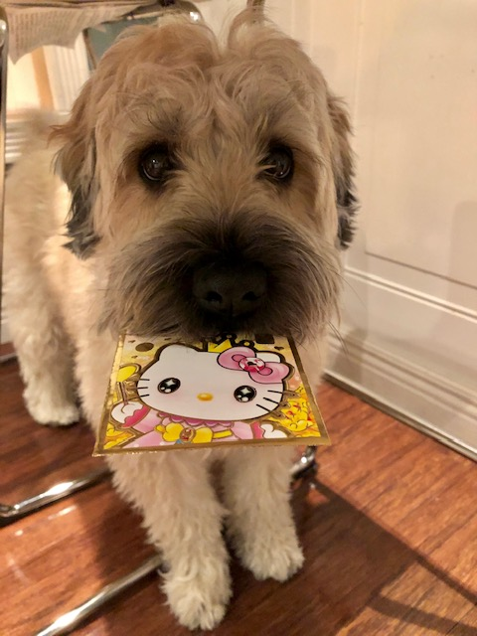

February 1st, 2022 will be the first day of the Lunar Calendar where many Asian countries celebrate their New Year! I will share the traditions that are celebrated in my family’s home countries of China and Vietnam.

The Lunar New Year is most commonly referred to as the Chinese New Year. It’s based on the lunar calendar and is celebrated on the first day of the first month in the lunar calendar. In the Western calendar, it usually occurs in late January or early February. Both Vietnamese and Chinese people share many similarities in the way they celebrate the new year. The New Year is the time for family reunions and paying respect to ancestors. According to the Chinese Calendar, the year you were born determines your personality. That’s because each year is represented by an animal in the Chinese zodiac. This year, 2022, is the Year of the Tiger.

Another major belief is thatthe bad luck and hardships of the previous year behind and look forward to a better year to come. As a result, two weeks before New Year, people spend lots of time cleaning their homes to remove bad luck from the previous year, making room for the coming year. Both Chinese and Vietnamese believe that what you do on the New Year determines your fate for the rest of the year. This leads them to appear their best with new haircuts, new clothes, improve their habits and pay great attention to how they speak and behave. People also try to pay off all debts from the previous year, so that they are ready to step into financial prosperity in the coming year.

They also believe that the first visitors to a family determine their fortune for the whole year; therefore, they like to invite someone of good morality to be the first ones visiting the house to bring them full blessings for the New Year. Children greet parents, grandparents, and elders with best wishes and receive red envelopes with money in return for good luck.

Both Chinese and Vietnamese decorate their houses with lucky colors like red and yellow. Additionally, fruit trees are planted in and around the home as symbols of fertility and fruitfulness. The most popular fruit decorations are peach blossoms, kumquat trees, and orange trees symbolizing the hope of prosperity and well-being.

On the street, people celebrate the day of the new year with firecrackers, drums, bells, and gongs to ward off evil spirits. There are also parades and lion dances in different districts of the cities.

Families come together for a large feast throughout the days of the New Year Celebration. Different foods have their significance for luck. For example, Rice Cake symbolizes “a better and more improved year'' long strands of noodle symbolizes “long life,” glutinous rice ball for ‘reunion,’ and dried oyster for “good business.”

New Year celebrations last for 15 days, and similar to the food, each day has its significance. At my home, on the first day, my brother and I had Rice cake for breakfast. Then, we wished our parents good health, luck, and prosperity. In return, our parents also gave us their wishes along with a few “Red Pockets” of money.

As uniquely rich as the Lunar New year is, schools often don’t give much awareness to it. As a result, many Asian-Americans can not properly enjoy the holiday due to conflict with school. This leads to many students having an internal conflict, as they have to choose whether to attend a school or take part in a holiday so meaningful to them. My Asian-American peers and I have a feeling of guilt if we were to skip school for the new year or miss the new year for school. Along with not having a day off for it, it is often not recognized in many schools. With around 10% of Boston’s residents and 7% of the entire Massachusetts population being Asian-American, the Lunar New Year deserves a day off in more local schools, including BISB. Asian American students in Boston, the US, and around the world, deserve to be able to celebrate their cherished New Year without any guilt.

If you meet someone who celebrates it, be sure to wish them a ‘Happy New Year!’